# The ultimate kit to build your own type texting 2d game in just minutes!

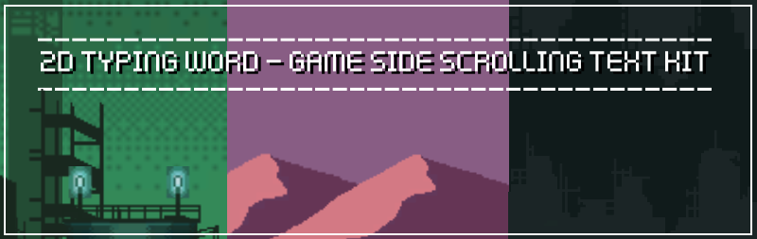

## **Are there any more features and versions planned?** We will be updating the asset from time to time, check the asset store for updates and to see version notes by clicking on the version notes (ex: v1.2 etc).

# REMEMBER that a **canvas** in the scene is needed for the package to work correctly, so you will need to always have a canvas in your scene!

**INTRODUCTION**

**Thank you for buying this KIT, we really appreciate your support.**

**Welcome to 2D Typing Game - Side Scrolling Font Text Typer KIT Template documentation. This will tell you everything you need to know about the KIT and how to start building your own game easy in 1-2-3.**

This is a kit which contains prefabs, models, scripts in C# to create your own 2D typing game or text word game where you have write the correct text and to get a high score each time you get it right before the text lands on the end of the screen. This KIT provides you with scripts, models, animations, textures, sprites, prefabs and everything to start your own game, including two modes and some example projects with also a menu included. You can drag and drop the prefabs to create your own game or just edit the example scene to your needs.

**CREATE YOUR GAME WITH EASE**

This pack is simple, yet very powerful to create any type of game mode. You have 3 beautiful scenes included with amazing art in the package in 2D.

**What can I create with this?**

This KIT is mostly used for creating a text word typing game however with some changes you can create anything you want. This KIT includes the models and ready to use prefabs to just drag and drop so it is easy to create your own game.

**Create a new empty project**

Create a new empty project, set defaults for 3D and Import this package into the NEW EMPTY PROJECT. **Please note:** Importing into an OLD Project may result in damaging your old project.

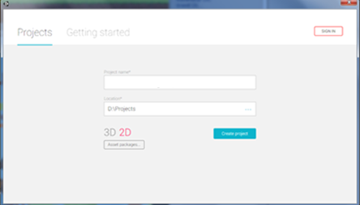

**Import Package to unity**

Import the package inside Unity using the import button, be sure that you select 3d and ALL are selected.



**Explanation of files**

**Audio folder**Audio folder contains all the KIT sounds and music including audio and sounds FX.

**GUIs folder**Contains the GUIs prefabs to use in game such as the button GUIs, crosshairs, full background images and such.

**Materials folder**Contains the materials for all your models and prefabs.

**Icons folder**Contains the 2D icons for your game such as the home button, restart button and such.

**Kenfonts folder**These are all the fonts included in the package that you can use in your game and create any word and text in these type of fonts, and they are made by (and thanks to) the awesome **kenney.nl!**

**Prefabs folder**Prefabs folder are the most important in your package, they are ready to use game objects and they come with collider, sometimes scripts and rigidbody so each prefab you drag into the scene it will be mostly ready to use and you only need to setup the settings inside in the script.

**Scenes folder**Folder will contain the example scene and the main menu which you are free to modify.

**Scripts folder**Important folder which contains IMPORTANT scripts for your game.

**Sprites folder**Includes the sprites from the package.

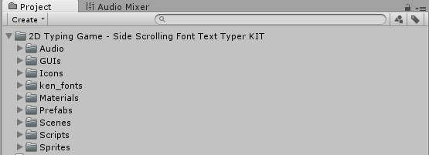

**creating your own canvas (how to do it - OPTIONAL)**

The canvas is important for this package as it needs to be in the scene always to make it work, otherwise the words will not spawn and you won’t see them and it will cause errors for you. The canvas is the area that all UI elements should be inside. The Canvas is a Game Object with a Canvas component on it, and all the UI elements must be children of such a canvas (taking directly from the Unity, lazyness)

To create a canvas, go to GameObjects then go to UI and then click on Canvas, and there you will have your Canvas in your scene. This will be used to spawn the text words with the Word Spawner, which we will be doing on the next step.

**Also, we included a canvas as a prefab which you can just drag and drop easy, so you won’t have to create a new canvas and go through all this, but if you do you know how too now.**

Be sure that your canvas is surely n the scene, because you will need to assign it to the Word Manager in the Word Spawner script, where it says “canvas” later on for the words to spawn on it.

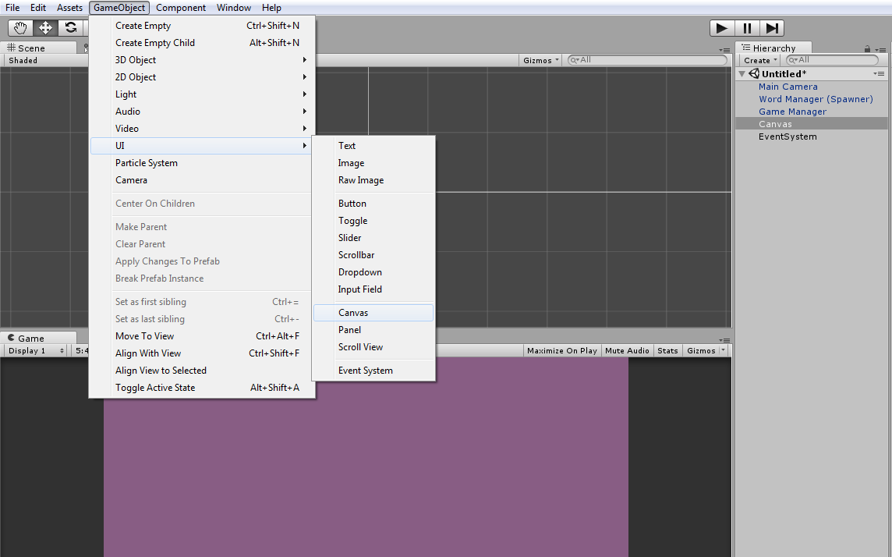

**This is an important step:**

If you created your canvas of did drag and drop the prefab of the canvas, to work fully you need to drag and drop your CANVAS INTO THE WORDMANAGER PREFAB, ON THE WORD SPAWER SCRIPT WHERE IT SAYS CANVAS. Otherwise, it won’t work. **See the next step below on how to set it up!**



**SETTING UP YOUR CANVAS (how to do it - OPTIONAL)**

## **IF YOU CREATED YOUR OWN CANVAS, DON’T FORGER to change its scale!**

As we said, we depend on the canvas of the scene for this package. What we need to do now is scale the canvas to the right size of the game, otherwise the text will be too big to fit the Main Camera. Go to the canvas that you just created and in the Canvas Render mode, change it from your default to **World Space**.

After that, go in the Rect transform part and we now need to change the scale. The scale of the canvas should be around; **X:1 Y:1 Z:1** so now we need to change it to; **X:** **0.01575 Y: 0.01413281 Z:** **0.015**

So what you need to do is change the Render mode to **World Space** and then change the scale of the canvas to**:**

**X:** **0.01575**

**Y: 0.01413281**

**Z:** **0.015**

Once you changed the canvas to that size, it should work properly when you set up the game. Remember that you change to its correct sizes, be sure your canvas is the same as the screenshot below.

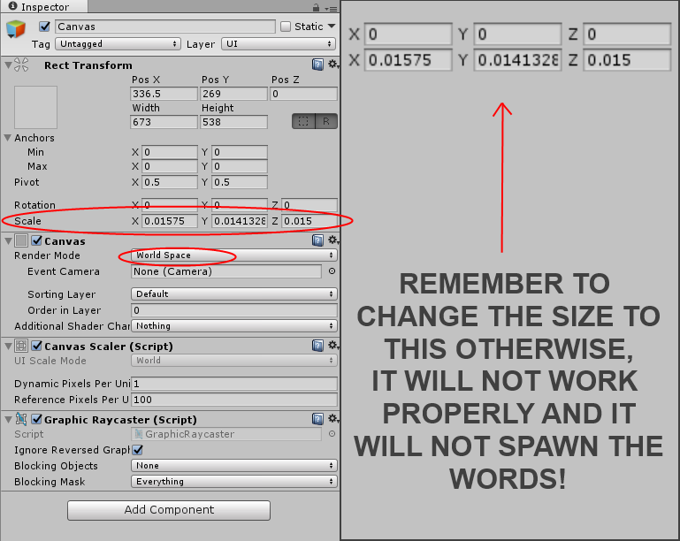

**Do you want to skip all this?** Then just drag and drop the Canvas Prefab located in the prefab folder.

**ASSIGNING YOUR CANVAS (how to do it - OPTIONAL)**

Now that you created and just set up your canvas, all is left to do is assign your canvas to the Word Manager (Spawner) prefab in your scene. All you need to do is drag and drop the Canvas in your scene that you created (be sure it’s the right size and you done the scale and put it to World Space) and put it in the Word Spawner

So let’s just check if everything is in order. You created your own canvas from the Gameobject > UI > Canvas. Then you changed the Canvas Render Mode to World Space. Then you set the scale correctly in the Rect Transform of the canvas (**X:** **0.01575 Y: 0.01413281 Z:** **0.015)** and lastly, you assigned the canvas in your scene to your Word Manager in the Word Spawner script where it says Canvas. All you need to do is drag and drop it in there.

**Also remind you that we included a canvas as a prefab which you can just drag and drop easy, so you won’t have to create a new canvas and go through all this and you can all skip this canvas part.**

Be sure that your canvas is surely in the scene, because you will need to assign it to the Word Manager in the Word Spawner script, just like in the screenshot below.

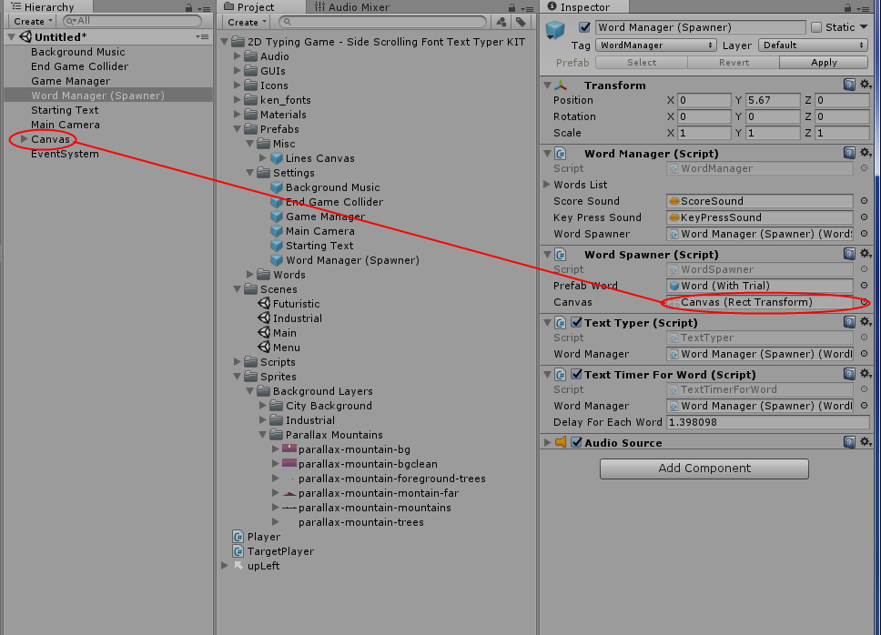



**CREATING YOUR very FIRST GAME EASY in minutes!**

This packages comes with all ready to use prefabs, so you can just drag and drop and only have to worry about creating the levels with sprites or such. This KIT will allow you to setup an easy 2D typing game where it spawns words and you have to type them fast before they reach the end line, with all the basic features included. So, how easy is to create a game just like the one below? It just took me about 3 minutes to set it up.

**Let’s see step-by-step...**

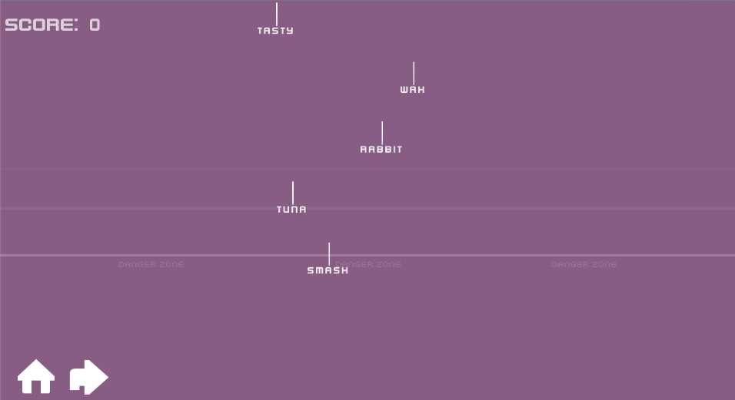

**Step 1:** Create a new scene, delete the main camera and go to the folder where everything is located, the prefab folder.

**Step 2:** Navigate to the Settings folder and drag and drop the Main Camera.

**Step 3:** In the same folder, drag and drop the Game Manager and Word Manager. These are the two important prefabs in your game. The word manager controls the words that spawn, and the game manager controls the game score and game end screen and such.

**Step 4:** Drag and drop the Canvas or the Line Canvas (which is the same, but with danger zone signs and lines) in your prefab (or if you created a new one, be sure that you followed the step before where you have to scale it, otherwise it will give you trouble) and go in the Word Manager in your scene. There, you will see a script called Word Spawner and it needs the canvas in your scene to spawn these words, so go ahead and assign your canvas that you put in your scene into the Canvas of this script.

If you done everything correctly, HIT PLAY and then you should have something like in the **screenshot above just only empty** but it should work correctly, the words will spawn and you can type them and they will be gone and a score will be added, but we need to end the game if the player fails to do so in the correct time, that’s where the End Game Collider comes in.

**Now as you can see it’s already finished, we need to add the End Game Collider so the game will end if the players fails to type the word before it runs off the screen or such.**

Now it’s time to add the End Game Collider.

**Step 5:** Go ahead and drag and drop the End Game Collider into the scene. Go into the scene you can set the End Game Collider anywhere you want in the scene Try to position it on the camera and a little below the camera so when the word disappear from the camera or hits a target then the game will end.

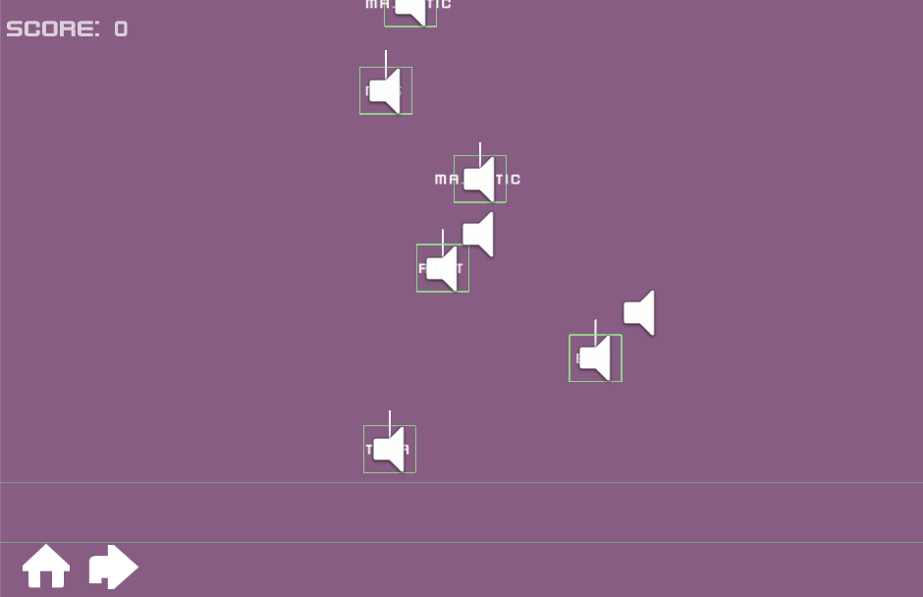

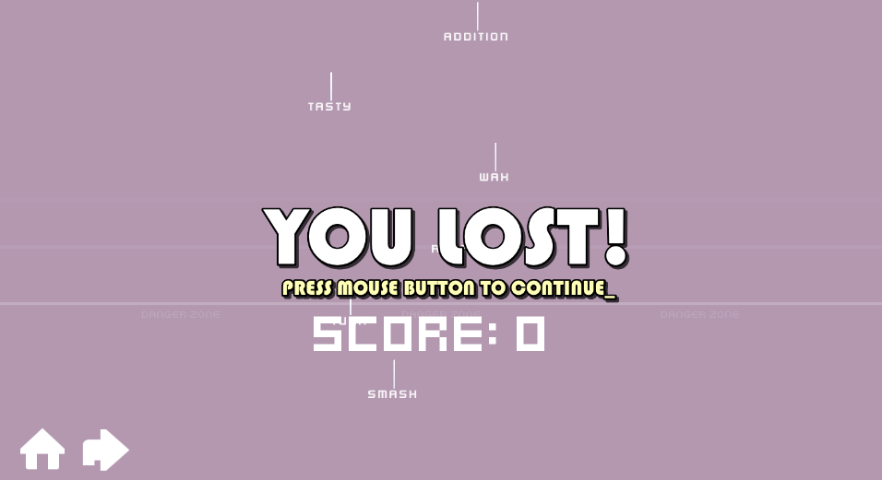

Once you added that, you can see that the game is yours and ready. The word text will spawn randomly and the delay speed for each word that spawns can be changed in the Word Manager. You need to type it fast to get a score otherwise once the text reaches to the End Game Collider, the game will end and an end game screen will display, which can also be changed in the Game Manager (along with other stuff too!).

So you get the idea now, right? Go ahead and add some more stuff and create your own game. Maybe add some sprites and background music. Oh yeah, there is another step...

**Now that you are almost done, all you basically need to do is add the other cool stuff such as background music and some sprites for your scene, use your imagination for that!**

**Step 6:** Go ahead and add some sprites and cool stuff, makes your game cooler and nicer. Also, drag and drop the Background Music and Starting Text in your scene. The background music plays and stops when the game ends, and the starting text will display a text and you can change it in the inspector to your needs to type a starting message for the players.

With some creativity and fun, you can create nice scenes like this below.

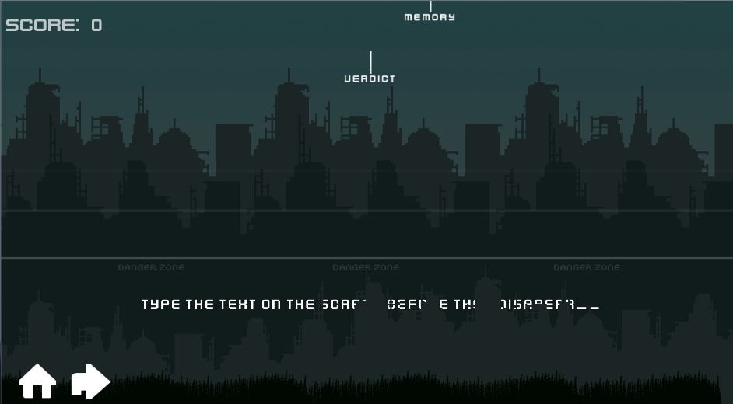

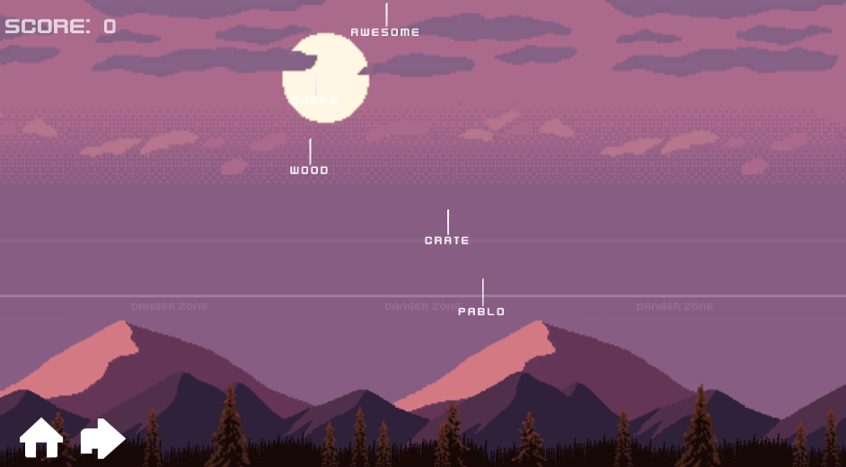

**How to choose your own words to spawn - IMPORTANT**

So, how do you choose your own words to spawn in this KIT? Simple.

There is a WordGenerator script which generators the random words and the WordManager gets the words from WordGenerator script. Go ahead and find the script WordGenerator (WordGenerator.cs) located in your scripts folder and open it up.

**You should see something like this screenshot below.**

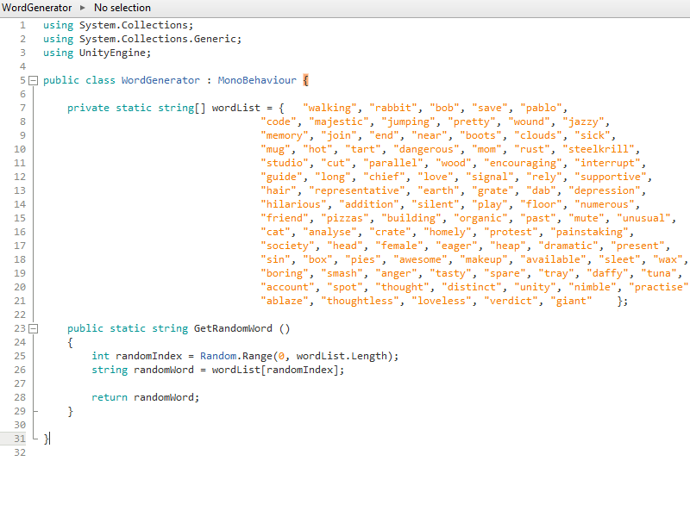

This is your script that will be generating words, all you need to do is change the words in the orange to your needs. You can create new words with doing the same , “a word” and so on.

You can open it up and create your own words that you want to spawn. Be sure that the words are in the correct order, so if you want to add new words you have to do add a (,) after each word and (“”) between each word - like this;

"walking", "rabbit", "bob", "save", "pablo", "code", "masjestic", "jumping", "pretty", "wound", "jazzy", "word", "word ", "word ", "word ", "word ", etc.

**QUICK VIEW SUMMERY ON HOW TO CREATE YOUR GAME!**

Well, you got the game going on easy so let’s go through it one more time and see how simple it is, but let’s make it simpler because the truth is we can!

**Let’s see step-by-step again and be sure you done everything right...**



**Step 1:** Create a new scene and delete the Main Camera.

**Step 2:** Go to the prefabs folder and drag and drop these prefabs into your scene:

* Normal Canvas
* Background Music
* Game Manager
* Word Manager (Spawner)
* Main Camera
* End Game Collider
* Starting Text

**Step 3:** Go in the Word Manager (Spawner) in your scene and drag and drop the Normal Canvas into the Word Spawner where it says Canvas.

**Step 4:** Position the End Game Collider to your needs and you can just start adding sprites and customize your game easy.

If you done everything correctly, HIT PLAY and then it should work correctly. The words will spawn and you can type them and they will be gone and a score will be added. When the words hit the End Game Collider that you positioned it before, then the game will end and display your final score and that’s it!

**EXPLANATION OF TAGs**

Some prefabs will be tagged with the required tagged to work correctly, for example for the text word that spawns in the scene is tagged with Text. The word manager prefab is tagged with WordManager, and the background music is tagged with BackgroundMusic and so on. These tags are important and be sure that all the prefabs that need a tag are tagged with the required tag.

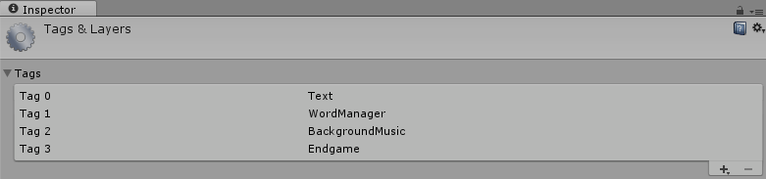

The **Text** tag is the word text that will spawn in the scene. You can find these word text in the prefab folder located in the Words folder. These are the words with fonts that will be spawned in the game.

The **BackgroundMusic** tag needs to be tagged with the Background Music (if you want to play a background music that is, so it can be destroyed when the game is won)

The **WordManager** tag needs to be tagged to the Word Manager (Spawner) prefab which will spawn the text words and such.

The **EndGame** tag needs to be tagged with the End Game Collider, so when the word text hits the End Game Collider, it will end the game and display the game end screen.

You can see the screenshot above (the first screenshot) to explain that each prefabs that need to collide or do an action needs to be tagged with the required tag. There are only 4 tags to use. The WordManager tag needs to be tagged to the Word Manager (Spawner) prefab which will spawn the text words and such, the Text tag which is the word text that will spawn in the scene, the BackgroundMusic tag needs to be tagged in the background music prefab in order to stop playing the music when the game ends and lastly the End Game tag that needs to be tagged with the End Game Collider, so when the word text hits the End Game Collider, it will end the game and display the game end screen.

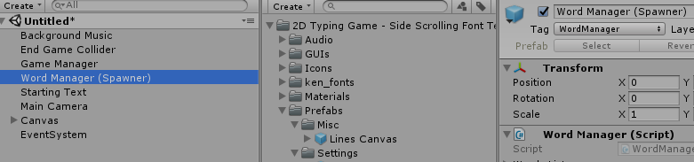

Also, remember that the tags are important to find your game objects, so be sure that everything is tagged with the required one. Otherwise it may not work.

**Finishing your game and f.a.q**

If you finished all the steps then you may have a basic idea of all the features in the KIT. Please note that you can use your own sprites instead. Below we will do the F.A.Q and hopefully answer any questions you may have regards the KIT. If you are in doubt or stuck, be sure to check out the F.A.Q below and be free to use the example scenes provided to learn from them. The example scenes and prefabs are a great way to learn more. Enjoy your game making journey!

**1. Who is this KIT made for?**

This KIT is made for anyone who would like to experiment, learn and create a similar or any other game. This KIT will provide you the scripts you need to create it for both new users and who are willing to learn more.

**2. What is this KIT focused on?**

The main reason this KIT was release was for creating any type of text typing game or word type learning game.

**3. Can I add my own sprites instead of the KIT’s ones?**

You can add as many sprites as you like and also use the ones provided.

**4. How do I change the background music?**

The background music is just an audio source which can be changed from there in the Background Music Prefab.

**5. How do I change the game end sound?**

The game end sound is a prefab that is located and can be changed in the Game Manager prefab where you see **End Game Sound Prefab**. From there you can also change the End game screen that displays in the scene, along with the score that displays in the end and score style of the game.

**6. Why is the game over screen displaying when I start the game?**

This can happen if you have not put a CANVAS in your scene you have not yet created one. Go to your prefabs folder and drag and drop a canvas into the scene, then assign it in the Word Manager in the Word Spawner script where it says Canvas.

**7. How do I change the game end GUI?**

The end game GUIs is located in the Game Manager prefab and can be changed from there. You have the background that will display when you end the game, the score board and the score which is Display Score which you can also customize to your needs.

**8. How can I change the score that displays in the scene and in the end?**

This can be changed in the Game Manager prefab, both the score that display in the game and at the end can be found there, the DisplayScore is the score that will display in the end and the ScoreStyle is the one that will display in the game when you play it, you can customize everything from the font, text, color and size.

**9. How can I change the fall speed of the word text that spawns?**

You can change the speed of the word text by pressing on the Word Text that you are currently using (can be found in the Word Manager in the Word Spawner script, where it says Prefab Word) and there is a prefab of the text you are spawning. Click on it and there you will find the Display Word script, which you can change the **fall speed** of the current text you are using from there. You will need to change each of the word speed in case you wish to make other ones.

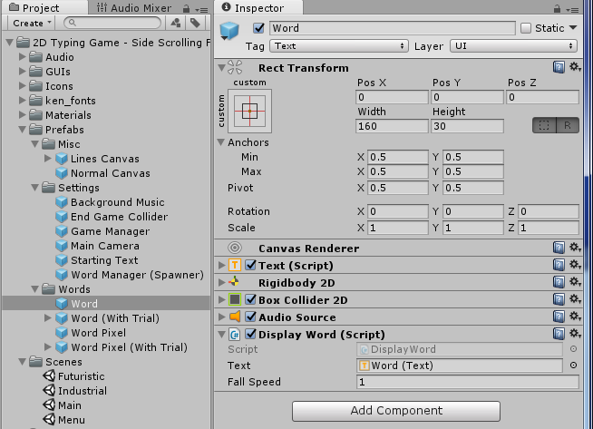

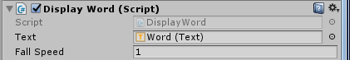

You can change the Fall Speed of the Word (Text) to make it faster or slower.

**10. How do I customize the word text?**

You can choose any word text that you want from the Word Manager where you have the Word Spawner script. There you have the Prefab Word and you can assign any word that you want, you can also create your own. You can customize the word text by pressing on it and just change it to your needs there. In the Word prefab folder you have 4 words that you can use as a start, two of them have a line renderer so when they drop it will display a cool effect with a line dropping on top of the text. **See the screenshot below.**

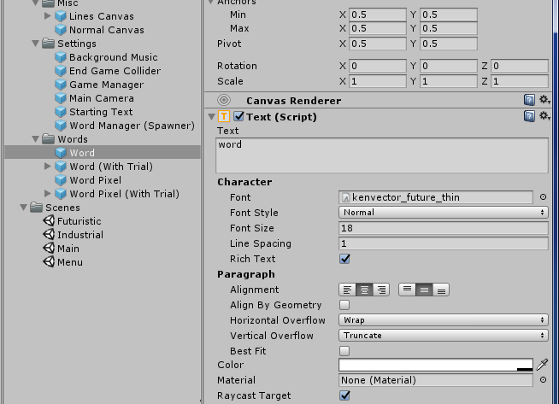

**11. How can I change the spawn time that it spawns for each word?**

Go to the Word Manager prefab and in the Text Timer For Words script there is a Delay for each word, this is the dealy and spawn time that spawns the words. You can increase it or decrease it and it will spawn faster or slower.

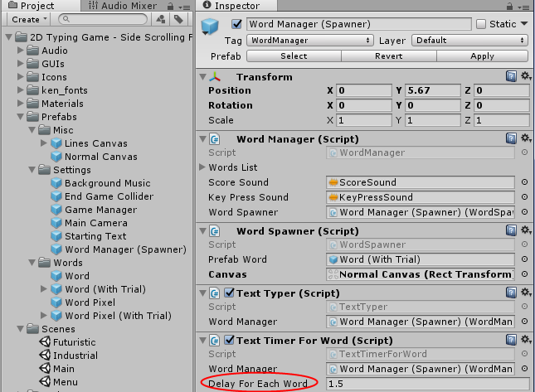

**12. How can I change the crosshair mouse cursor?**

You can change it from the Main Camera from the Crosshair script. There you can also set the size of the crosshair mouse cursor.

**13. How can I change the sound that plays when I get a score?**

This can be changed in the Word Manager prefab where is the Word Manager Script located at the top. There you can change the score sound that plays when you get a word score and the key press sound.

**14. How can I change the key press sound?**

This can be changed in the Word Manager prefab where is the Word Manager Script located at the top. There you can change the score sound that plays when you get a word score and the key press sound.

**15. Can I use a different word text font?**

Yes, all you need to do is go in the Word Prefab folder and change the font for the word you are currently using in the scene. Otherwise if you wish to assign an new word, all you need to do is go in the Word Manager in your scene and drag and drop the word you want to use (you have 4 from the Word Prefab Folder) into the Word Manager’s word spawner script where it says **Prefab Word**.

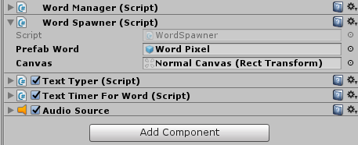

**16. How do I change the score that is displayed?**

Go to your player target in your scene and in the inspector you should see Display Score and Score Style. You can change them to your needs from there.

**17. How do I change the screen fadeout that appears in the begging on the Main Camera prefab?**

In the inspector of the Main Camera, there is a script called FadeScreen. There you can choose which image you want to fade and how long till the fade last.

**18. When I lose and the game ends, it displays the error ‘Level Menu (1) couldn’t be loaded etc.”?**

You need to assign the menu to the build. Go to the build settings and add the Menu and scenes and then try again. Whenever the game ends it will take you back to the menu screen.

**19. When I play the game it just displays the end game screen?**

Be sure that you have a CANVAS in your scene and that the CANVAS that you have is assigned in the Word Manager (Spawner) in the Word Spawer script where it says Canvas. Drag and drop your canvas that you have into the canvas of the prefab. If you don’t have a canvas, just drag and drop one from the Important Canvas folder.

**20. Why when I advance to next level after I finish the game gets stuck or gets a white screen?**

You may need to add your levels to the build settings. Go to file and go to Build Settings and add the scene by pressing Add Open Scenes.

**21. How do I change the font of the words?**

To change the font of the word, you need to go to the Word folder and click on a word. Then in the Text script just change the font from there, you have 11 fonts to choose from and a default Arial font.

**22. How do I choose the words to spawn?**

There is a WordGenerator script which generators the random words and the WordManager gets the words from WordGenerator script. You can open it up and create your own words that you want to spawn. Be sure that the words are in the correct order, so if you want to add new words you have to do add a (,) after each word and (“”) between each word - like this; "walking", "rabbit",

**23. How do I change the buttons on the screen? (OnScreenButtons)**

You can find that in the Main Camera. There is an OnScreenButtons script and there you have the Home Texture and the Restart Texture. Click on the Home/Restart texture and just add an image of your choice. You can also change the hover image so when the mouse hover over it, it will display another image.

**23. How can I change the Main Camera to be closer and such?**

Since the camera is Orthographic, you can just change the size. However, that will just make the screen closer and the words bigger. If you want to make the words spawn bigger or such you need to edit the canvas settings in the Transform. If you for example change the Canvas width, then the word text will spawn closer together.

**24. When I create my own canvas, the words get bigger and I get the end screen?**

Since the words are already set as prefab, you can just drag and drop the Canvas that is included in the package because you need to set the scale down for the canvas (Since it uses the canvas to spawn the words). Otherwise, you have to make the canvas as Word Space and scale down the canvas a little.

** We will update this F.A.Q with any questions you may have or ask us for other to see if it is not listed here. If you have any questions regarding this package or anything else, please don’t hesitate to contact us at **Steelkrill.com. \*\***

**Will this pack be updated and do you have any more planned features?**

This KIT is still young and new and needs to grow and we plan on updating this package. We are working on improving this KIT and if any of you have any suggestions or feedback please don’t hesitate to let me know. We will do our best to update the KIT frequently and even plan on adding loads more. If anyone have any inquires, if someone is missing or you have any questions or feedbacks please don’t hesitate to contact us.

Hope you enjoy your game making journey and I wish to thank you very much for all your support. Have a great and fantastic day everybody! If you need anything, do not hesitate to contact.



**Thank for your purchase and enjoy. Happy game making journey!**